# **Architecture Catalogue on NIGOV Windows 10**

## ---These steps require an admin account. Without one you will not be able to setup unless IT Assist open up more access to the following tools---

## Download XAMPP and install:

<https://www.apachefriends.org/download.html> download windows 10 version. XAMP comes with PHP and MySQL (actually Mariadb) and is used to simulate an apache server locally.

Install making sure you install as different user and put in your admin credentials.

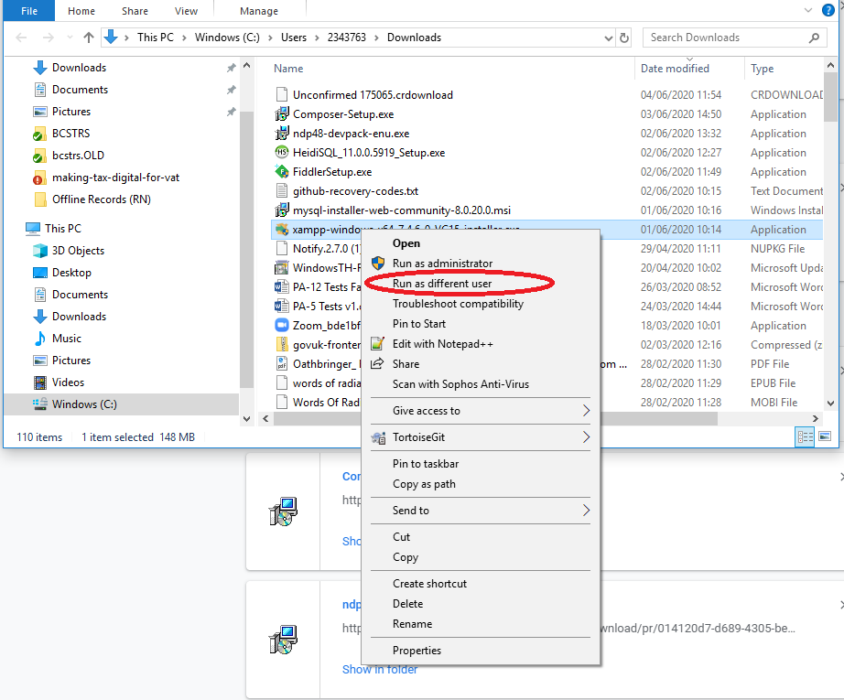

Complete the installation, noting that everytime you wish to use XAMPP you must open it as an admin user or it will be blocked.

## Add PHP to our Windows 10 command Path:

We need to be able to execute PHP commands via the command line on Windows and to make this easier we associate PHP to the new PHP executable we got with XAMPP.

Navigate to **Control Panel\All Control Panel Items\System** Then select “advanced system settings”.

Then “environment variables”

Then select “PATH” then “Edit” and add the link to the XAMPP PHP, which by default is C:\xampp\php

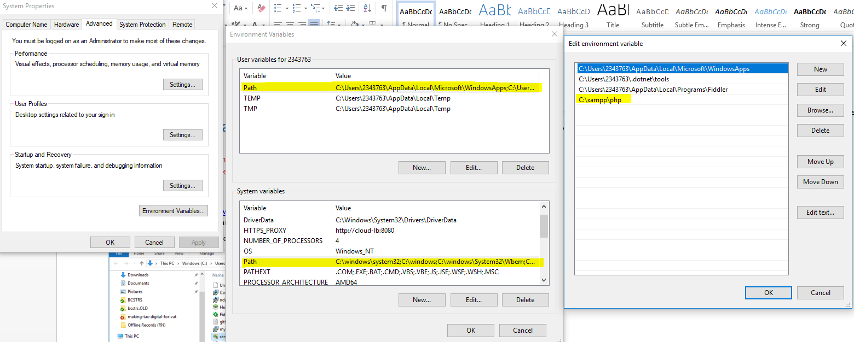

I did this for both the “user variables” and “System Variables” Path just to be sure.

## Download the Architecture Catalogue project.

Next we want the actual project pulled down. Sites in XAMPP usually live in the htdocs folder so navigate there. C:\xampp\htdocs. You can do this via command line or tortoise git or whatever your preference is.

git clone https://github.com/dof-dss/architecture-catalogue.git

## Download Composer.Phar

This part is particular annoying. Due to the restrictions I was unable to successfully install composer for windows installer. So what you have to do is download the composer.phar file itself.

<https://getcomposer.org/download/>

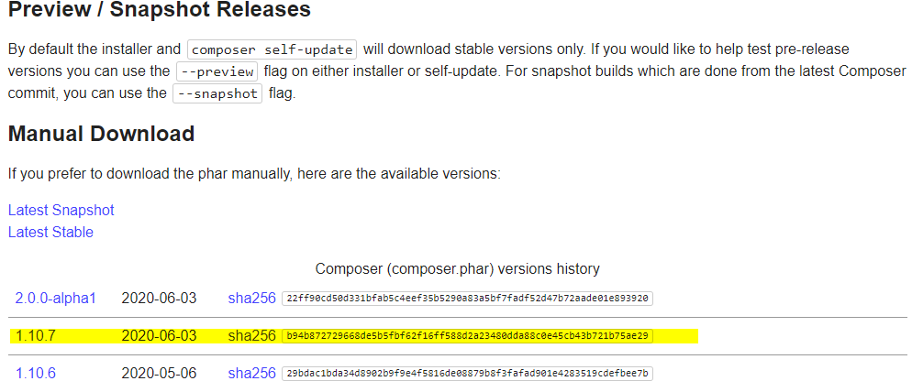

Once the composer.phar is downloaded move it into the project directory C:\xampp\htdocs\architecture-catalogue.

## Running Composer

Next open cmd line as a different user (Admin user)

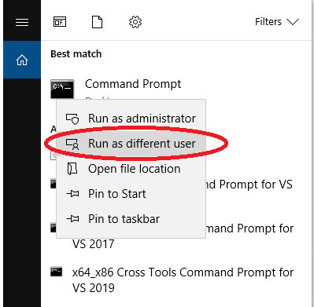

Navigate to where we just put the composer.phar.

Cd C:\xampp\htdocs\architecture-catalogue.

From here run the following command.

php composer.phar install

While here we might as well copy the .env file. So run the following command.

copy .env.example .env

and generate a new application key

php artisan key:generate

## Setting up our hosts and httpd-vhosts.conf file.

We need to configure a few files so the url we want points to the files we want.

Select windows search and type “run” select the run app and type: C:\Windows\System32\drivers\etc

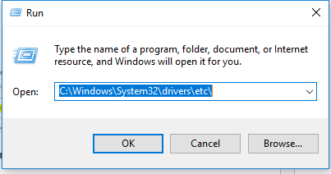

Open the hosts file as an admin. I used Notepad++ for this works well.

Add the following line. 127.0.0.1 architecture-catalogue.localhost

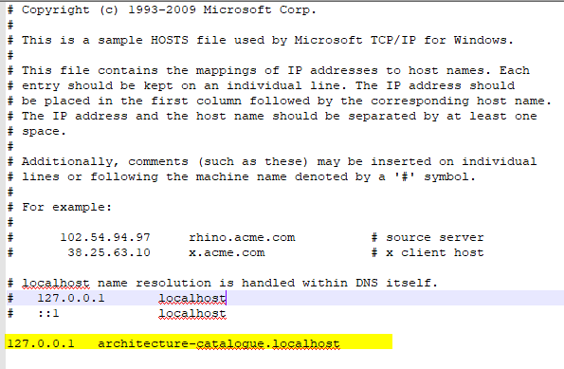

Note the name could be whatever you want but this will be the local url for the site. Save as admin and close.

Next we need to update our Apache vhost file. Navigate to C:\xampp\apache\conf\extra. Open httpd-vhosts.conf.

Add the following:

<VirtualHost *:80>

DocumentRoot "C:/xampp/htdocs/architecture-catalogue/public"

ServerName architecture-catalogue.localhost

</VirtualHost>

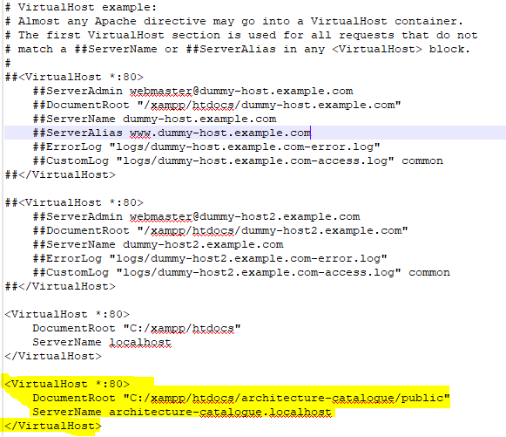

Save and exit.

## Run XAMPP

Now we have everything but the database setup now we can see if the site is running and that we can access it. Make sure you run XAMPP as an admin user or it will be blocked.

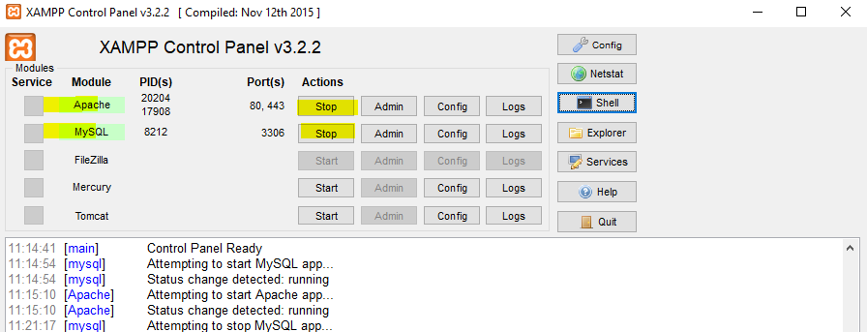

Under actions select “Start” for both Apache and MySQL, if working the module boxes will appear green. If not green you might need to restart as sometimes other programs block the ports used by Apache.

So at this point we are running a “fake” local server of Apache on our machine.

If you go to a web browser now and put in the URL of the site which we added earlier we should see something.

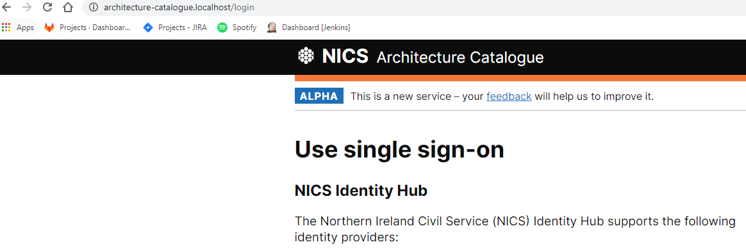

## Database Fun.

Nearly there! Chances are you seen something different in the last screen probably a 500 page because there is no database connected yet. To fix that we go to the XAMPP control panel and select the “admin” button along the MySQL column.

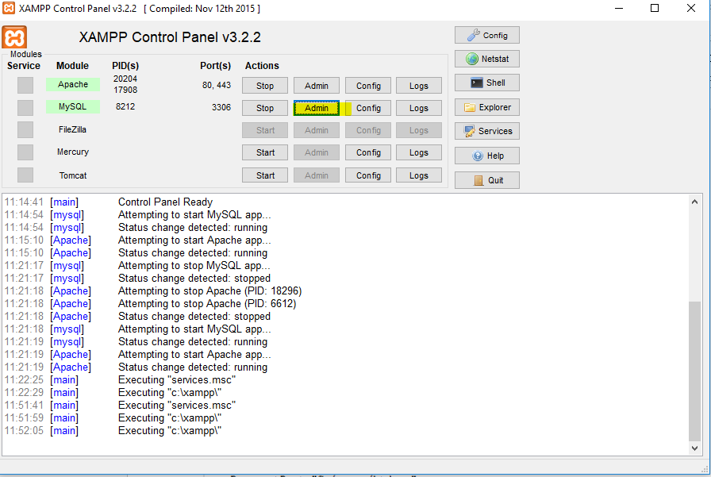

It will load the following page.

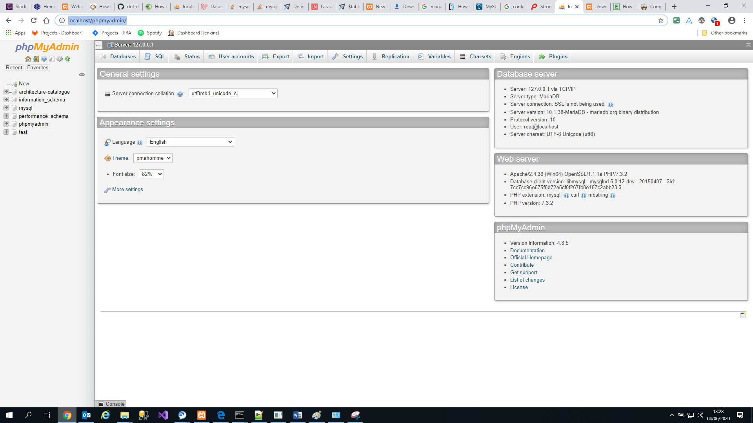

From here select “databases” and create a new one with an appropriate name.

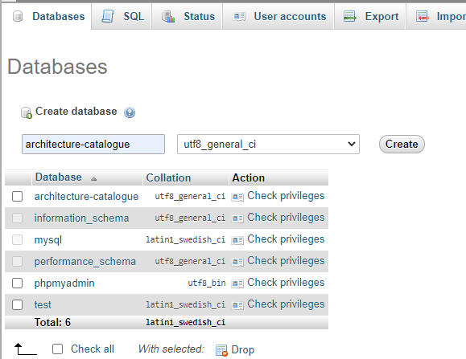

And then select create! Empty Database is now created.

Next navigate back to our project directory. C:\xampp\htdocs\architecture-catalogue

And open the .env file using notepad++.

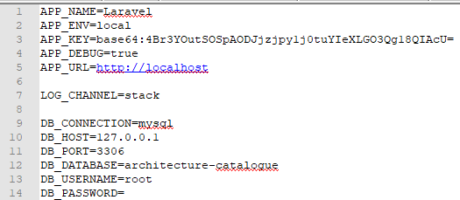

For the DB_DATABASE add in the name of the one you just created. This simply hooks up the DB to PHP Laravel.

While we are here we need to add some new environment variables used by one of the migration scripts

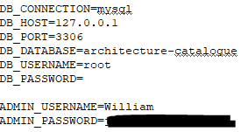

Add the “ADMIN_USERNAME” and “ADMIN_PASSWORD” fields.

Next we need to migrate the database so our empty DB gets populated with tables and maybe seed data. To do this we are back to the console window again (as admin ofcourse!). Navigate back to the project folder. cd C:\xampp\htdocs\architecture-catalogue and run php artisan migrate

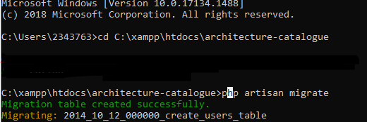

You should see the tables being migrated correctly. And if you check phpMyadmin again you will see tables in the database.

